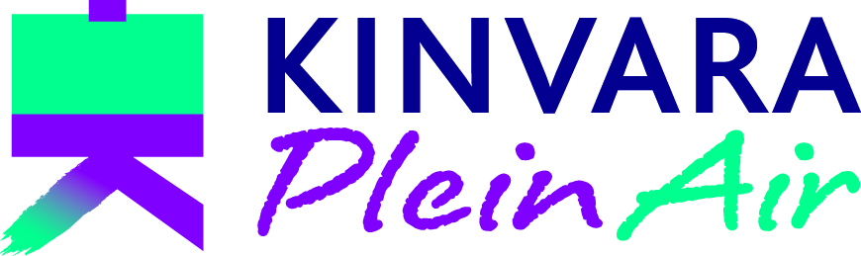 | Booking  Form | 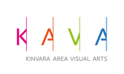
See Kinvara Plein Air 2023 Brochure for details and conditions

Name
Address
Mobile phone no
Email address
 | Yes |  | No
I am willing to be added to a What’s App group (x)
I am over 18 (x)

Please indicate (x) which workshop/s and event/s you wish to book:

Date | Tutor | Location | Fee | Tick | Due with booking | Balance by  1 April
Registration for KPA ‘23 | n/a | All | €15 | X | €15 | -
Workshops:
Sat. 3 June  10am-4.30pm | Geraldine Walsh | Kinvara Village | €65 |  | €25 | €40
 | Mavis Gormally | Thoor Ballylee | €65 |  | €25 | €40
 | Steve Browning | The Burren/  Corcomroe Abbey | €65 |  | €25 | €40
Sun. 4 June  10am-4.30pm | Steven Browning | Kinvara Village | €65 |  | €25 | €40
 | Roisin Cure | Thoor Ballylee | €65 |  | €25 | €40
 | Geraldine Walsh | The Burren/  Corcomroe Abbey | €65 |  | €25 | €40
Mon. 5 June  10am-4.30pm | Roisin Cure | Kinvara Village | €65 |  | €25 | €40
Other events:
Fri. 2 June 7.30pm | Opening Reception  (booking required) | KAVA Courthouse Kinvara | Free |  | - | -
Sat. 3 June  8pm | Social Dinner  (booking required) | Pier Head Restaurant | €35 |  | €35 | -
TOTAL DUE WITH BOOKING (ONCE NOTIFIED OF YOUR PLACE/S) |  |  |  |  |  | Invoice for balance will follow

Please return the completed form to kinvarapleinair23@gmail.com

